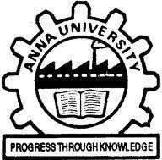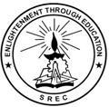 **SRI RAMAKRISHNA ENGINEERING COLLEGE**

**COIMBATORE – 641 022**

**BONAFIDE CERTIFICATE**

**16EC258- MINI PROJECT II**

Certified that this 16EC258 - Mini Project - II Report **“RETAIL DEMAND FORECASTING USING CNN-LSTM MODEL”** is the bonafide work of **KARTHIK K (1902102), NITHN SOUNDAR S J (1902132), RITHICK ROSHAN R (1902156)** who carried out the project under my supervision.

|  |  |
| --- | --- |
| **SIGNATURE** | **SIGNATURE** |
| **Mr. T. Rajasekar, M.Tech,** | **Dr.M.JAGADEESWARI,M.E.,Ph.D.,** |
| **Assistant Professor** | **Professor** |
| **Supervisor** | **Head of the Department** |
| Department of ECE | Department of ECE |
| Sri Ramakrishna Engineering College | Sri Ramakrishna Engineering College |
| Coimbatore - 641022 | Coimbatore - 641022 |

**Submitted for the Mini Project Viva-Voce Presentation held on ________________**

|  |  |
| --- | --- |
|  |  |
| **INTERNAL EXAMINER** | **EXTERNAL EXAMINER** |
|  |  |
|  |  |
|  |  |